Vendor Performance Report
Prepared by: Asha Das
Reporting Period: 01-11-2025 to 01-12-2025

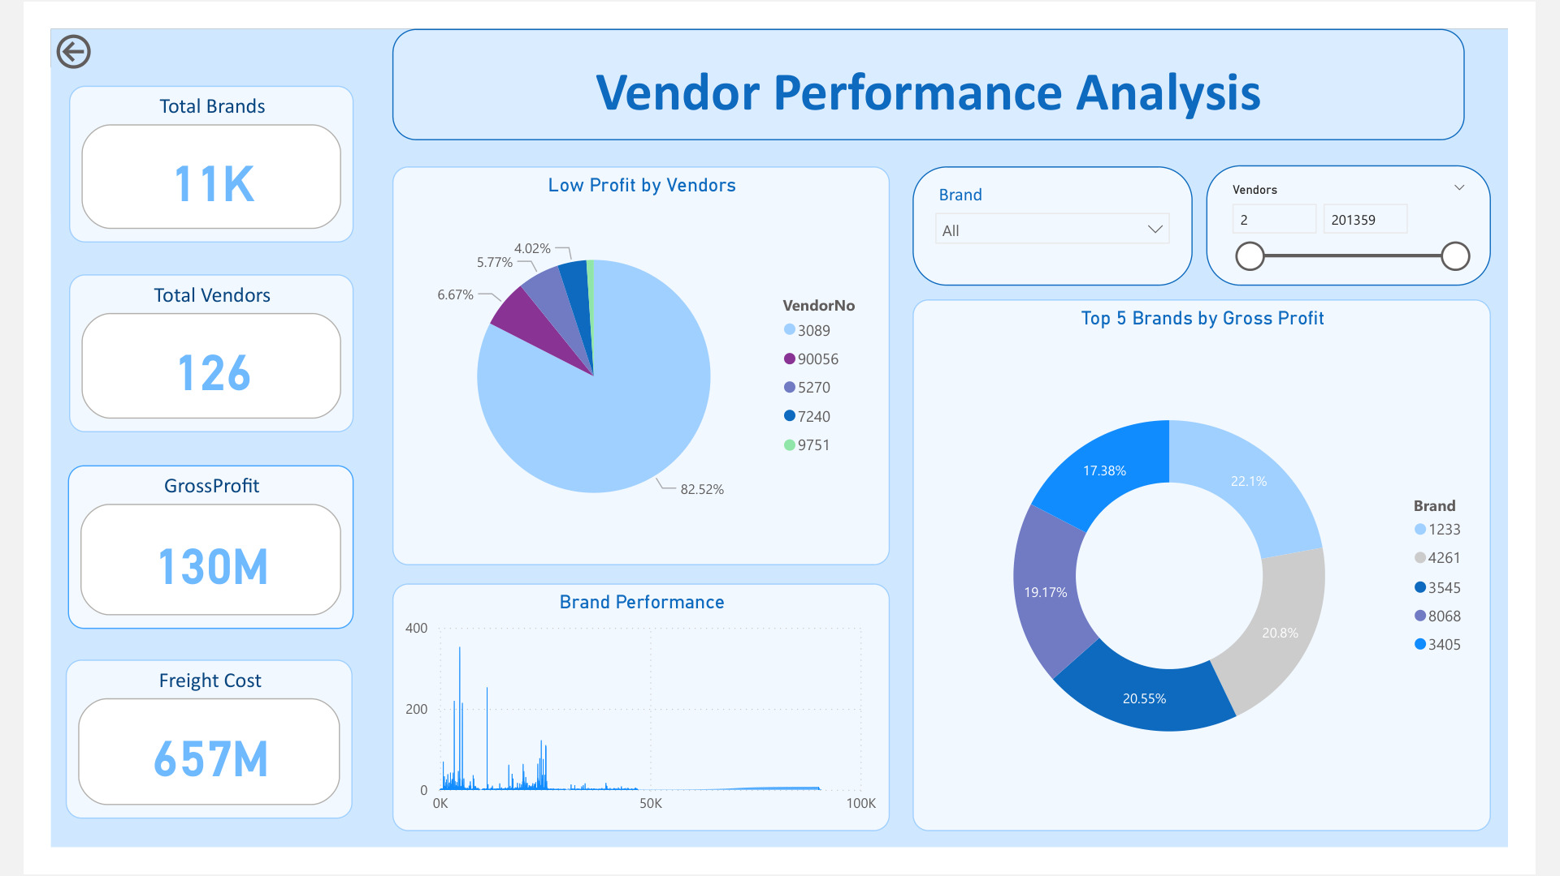
Dashboard Overview
This dashboard presents vendor performance metrics including total brands, vendors, gross profit, and freight cost. It highlights top-performing brands and identifies low-profit vendors.

Key Insights & Analysis
- Vendor 3089 has the highest low-profit contribution (82.52%), requiring performance review.
- Brand 1233, 4261, and 3545 contribute over 63% of total gross profit, showing high profitability potential.
- Freight cost (657M) is significantly higher than gross profit (130M), impacting overall profitability.
- Vendor count of 126 shows wide supplier base, requiring selective optimization.

Focus Area | Recommendation
Vendor Performance | Renegotiate contracts and evaluate low-performing vendors.
Logistics | Optimize freight cost by reviewing shipment methods.
High Performing Brands | Increase investment in top-performing brands.
Monitoring | Apply vendor scorecard monthly to track efficiency.
Conclusion
Vendor performance indicates strong brand contribution but highlights major losses due to freight costs. Optimizing vendor contracts and focusing on high-performing brands can increase overall profitability.

